# Sharepoint 2010 Responsive Mater Page- Step by Step Guide

# - Sasikumar, SharePoint Developer

***Creating Master Page***

**Step:1**

Download the ***Responsive Master Page Template.zip*** here.

**Step:2**

Go to your ***site collection*** and navigate to ***Site Settings***

**Step: 3**

(Make sure you have enabled the ***publishing future*** in site collection level)

Select the ***Master pages and page layouts*** option under Galleries

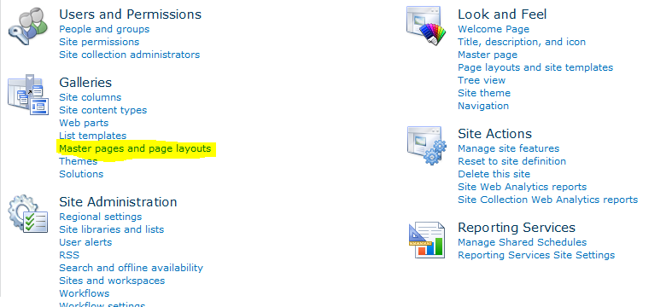

**Step: 4**

Open the downloaded zip file and copy

***Responsive Master Page Template->MasterPage->bootstrap*** and upload it under the master page list

(Make sure you have uploaded the “bootstrap” folder. Inside the folder, one master file will be there)

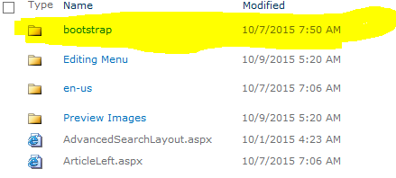

Step: 5

Click ***All Site Content*** link from Quick Launch pane. (Site Collection Level)

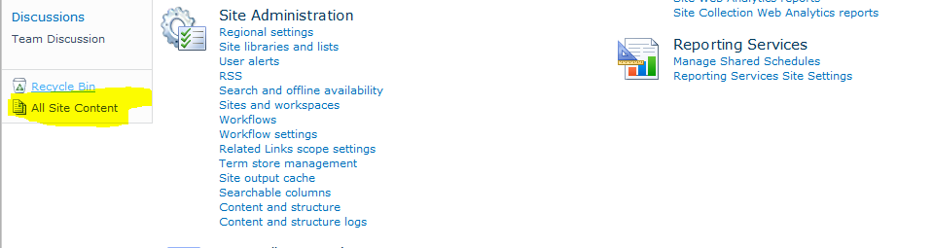

Step: 6

Select ***Style Library*** list to upload the bootstrap styles

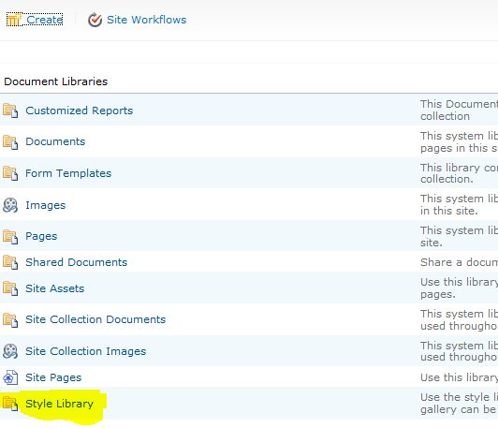

**Step: 7**

Open the downloaded zip file and copy

***Responsive Master Page Template->StyleLibrary->bootstrap*** and upload it under the Style Library list

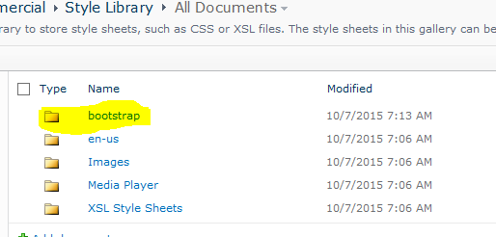

(Make sure you have uploaded the “bootstrap” folder. Inside the folder, img, styles, scripts folders will be there.)

**Step: 8**

***Check In*** all the uploaded files and folders and ***approve*** it.

Now your responsive Master page is ready.

Note: Set this master page as default master page to apply this responsive template to all sub site and site pages.

Please follow the ***below steps*** to apply this master page for ***individual site pages***. (Better apply this master page for user level pages)

***--Creating Site Page with Responsive Master Page***

**Step: 1**

***Create a site*** under the above site collection.

**Step: 2**

Open the downloaded zip file and copy

***Responsive Master Page Template->SitePage -> ResponsivePageTemplate.aspx*** and use this template for your site pages.

**Step: 3**

Create your own ***html5/responsive content under “contentplaceholdermain”*** and publish it.

***Desktop View: (New and Old site difference)***

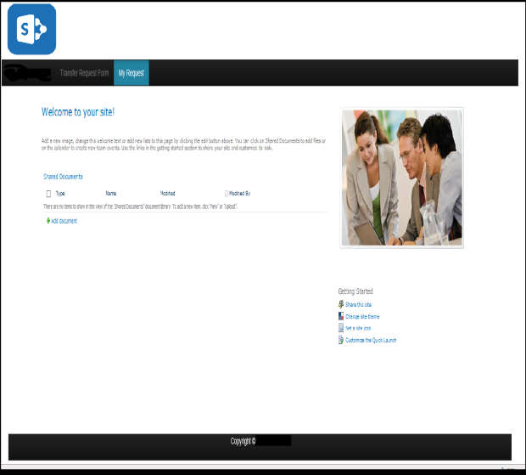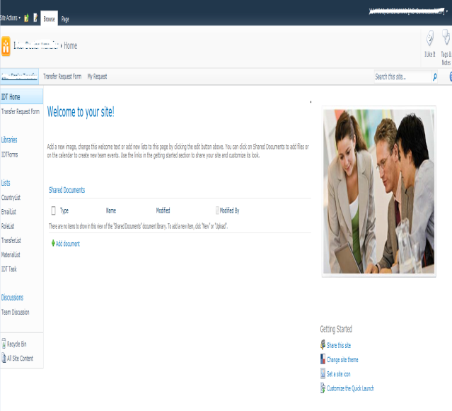

***Mobile/Tablet View:***

Top link navigation appearance will change like below for mobile/tablet view

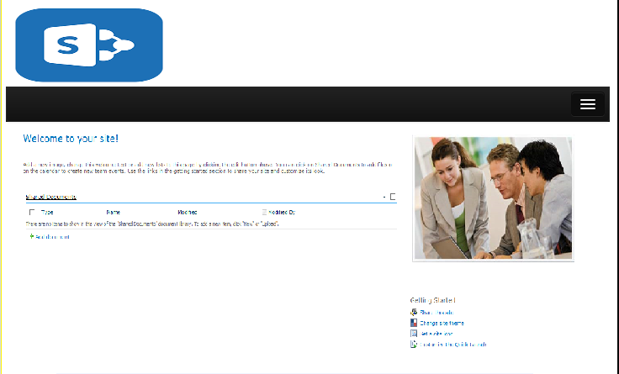

If you want to change the ***Site logo*** find the below code in your master page and change the LogoImageUrl.

<SharePoint:SiteLogoImage name="onetidHeadbnnr0" id="onetidHeadbnnr2" LogoImageUrl="Logo.png" runat="server"/>

Set ***Master page file Url*** like below to inherit the above responsive master page

<%@ Page language="C#" MasterPageFile= ../../_catalogs/masterpage/bootstrap/bootstrap.master meta:progid="SharePoint.WebPartPage.Document"

inherits="" %>

***--Responsive master page and site template is ready now.***

***--Design your own content for your site and change FavIcon and Site Logo for better appearance.***

***--The site is totally responsive and it will work with all devices.***

**Designing another SharePoint master page. Will update you all very soon.**